Headings Pane and Document Project

Eduardo writes:
I would like to start writing a novella using Atlantis. Could you please indicate to me the best way to go about it? For example, creating one file per chapter and have them organized in Control Board.
You cannot organize files using the Control Board, just Headings. To combine files, you may use Document Project.
Admin writes:
In my opinion, creating multiple files would be counterproductive.
Contrary to the admin I am of the opinion that splitting longer documents into single files, where each file represents a chapter of the document, has some advantages.
Robert links to a file which suggests:
“Instead of having a separate Word document for each of your chapters, I would highly recommend instead writing your manuscript as a single Word document with chapter breaks. Otherwise, changing even the smallest details will be a nightmare. (For example, if you want to change a character’s name, you’d probably have to Find-Replace every chapter).”
This is not true for AWP (and not even for MS Word, at least when using a Master Document). See
https://www.atlantiswordprocessor.com/en/help/control_board_findreplace.htm
The Find/Replace panel: This panel can be used to search the active document or all open documents for text or formatting, review the results, and optionally replace them with new text or format them:

Luckily with AWP you are able to decide yourself if you prefer to structure your documents by using headings in the Control Board or combining files in a Document Project.
Headings: Refer to
https://www.atlantiswordprocessor.com/en/help/control_board_headings.htm
The Headings panel of the Control Board: This panel displays the document structure as an outline according to the various document heading levels and captions. You can use Drag & Drop in the Headings panel to reorder the structure of the active document.
Looks like a traditional Two-Pane Outliner but controls headings instead of files.
https://www.atlantiswordprocessor.com/en/help/collapsible_headings.htm
Collapsible headings: When you want to focus on certain parts of a long document, you can temporarily collapse the document parts that you currently do not need.
This can be useful when (distraction-free) editing a document.
It can also be helpful if you publish manuals, work instructions or some kind of learning material in the .docx documents format. This gives the reader the possibility to first have an overall (collapsed) view, then a detailed (expanded) view of particular themes.
Technically this is One-Pane Outlining. As far as word processors are concerned, to my knowledge, only MS Word and Atlantis WP offer this feature.
Files: Refer to
https://www.atlantiswordprocessor.com/en/help/doc_projects.htm
Document projects: At times, you will be working on documents that are linked to one another in some way. For example, you might be working on several documents concurrently, each representing individual chapters of a book. You will often want to open all these related documents together. This is done by including them in an "Atlantis Document Project".
Unfortunately the files of a Document Project cannot be ordered in a hierarchical structure, only in sequential order. You cannot outdent/indent them to distinguish between main chapters and subchapters as it is, for example, done in AWP Help.
Compare Document Bar and AWP Help ….
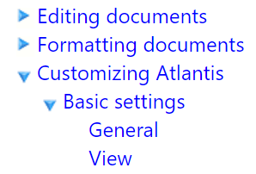
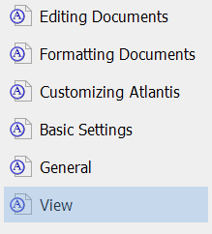 Flat Outdented/Indented
https://www.atlantiswordprocessor.com/en/help/operations_on_multiple_docs.htm
Combine Into One Document: Merges the selected documents into a new document. As an example, you might wish to merge individual chapters of a book into one document before saving it as eBook.
After combining the files, you may update Table of Contents and Index of the whole document.

Of course you can combine a Document Project and the Headings Panel of the Control Board.
Or you can simulate a combination:
- Use Level 1 headings for chapters (Level 2 for subchapters).
- Split the chapters using page/section breaks.
- Set the Headings Pane to show only levels 1,2.
- Only use lower levels of the headings as collapsible headings within a chapter.

