Tagging

“In information systems, a tag is a keyword or term assigned to a piece of information (such as an Internet bookmark, digital image, database record, or computer file). This kind of metadata helps describe an item and allows it to be found again by browsing or searching.”
See https://en.wikipedia.org/wiki/Tag_(metadata) for more information about tagging.
Example: You write a novel divided into chapters and you want to list all the chapters where a specific character is mentioned.
How could this be achieved in Atlantis Word Processor?
Lets suppose that the chapters are parts of a single file. So we tag each chapter with the tags for the characters mentioned in this chapter. We ought to use hashtags (with a “#”) because we don’t want to get a long list of all the occurrences of a specific characters name. Now we can use the Find/Replace panel of the Control Board to search for the chapters with a specific characters name.

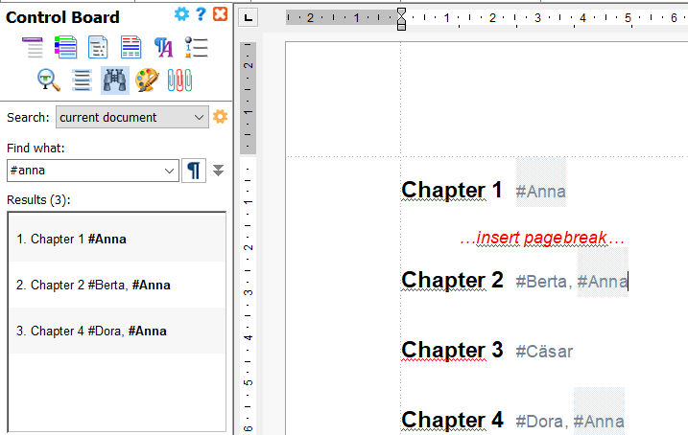

Since it seems to be more flexible to divide a publication into single files, representing chapters, I suggest to use a single file for each chapter and combine all files to an Atlantis Document Project. Fortunately it is possible to search “all documents” in such a project.

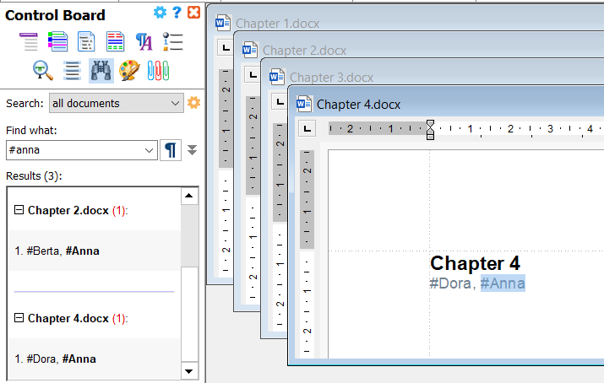
Now we may eliminate the hashtags (only setting the font color to white does not really satisfy). Note that tags are just keywords.
Select File – Properties… and place the appropriate tags/keywords.
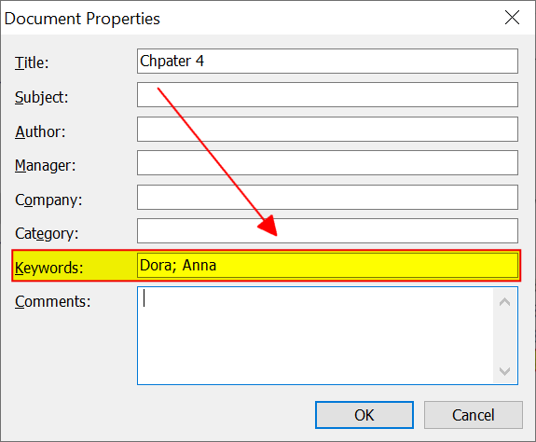
But now the Find/Replace panel will not find any matching entries if we search for these keywords.

Windows Explorer
Now we put the project files into one exclusive folder and make a few changes to the appearance of the Windows Explorer. Make sure to save the files as MS Word .docx.
Add a Tag column:
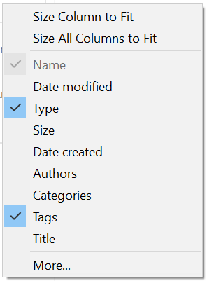
Group the entries by Type and sort them by Name:
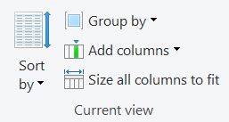
Then open the Details pane:
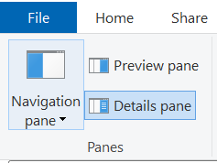
Now we can
- Add/remove tags
- Filter the files by tag names
