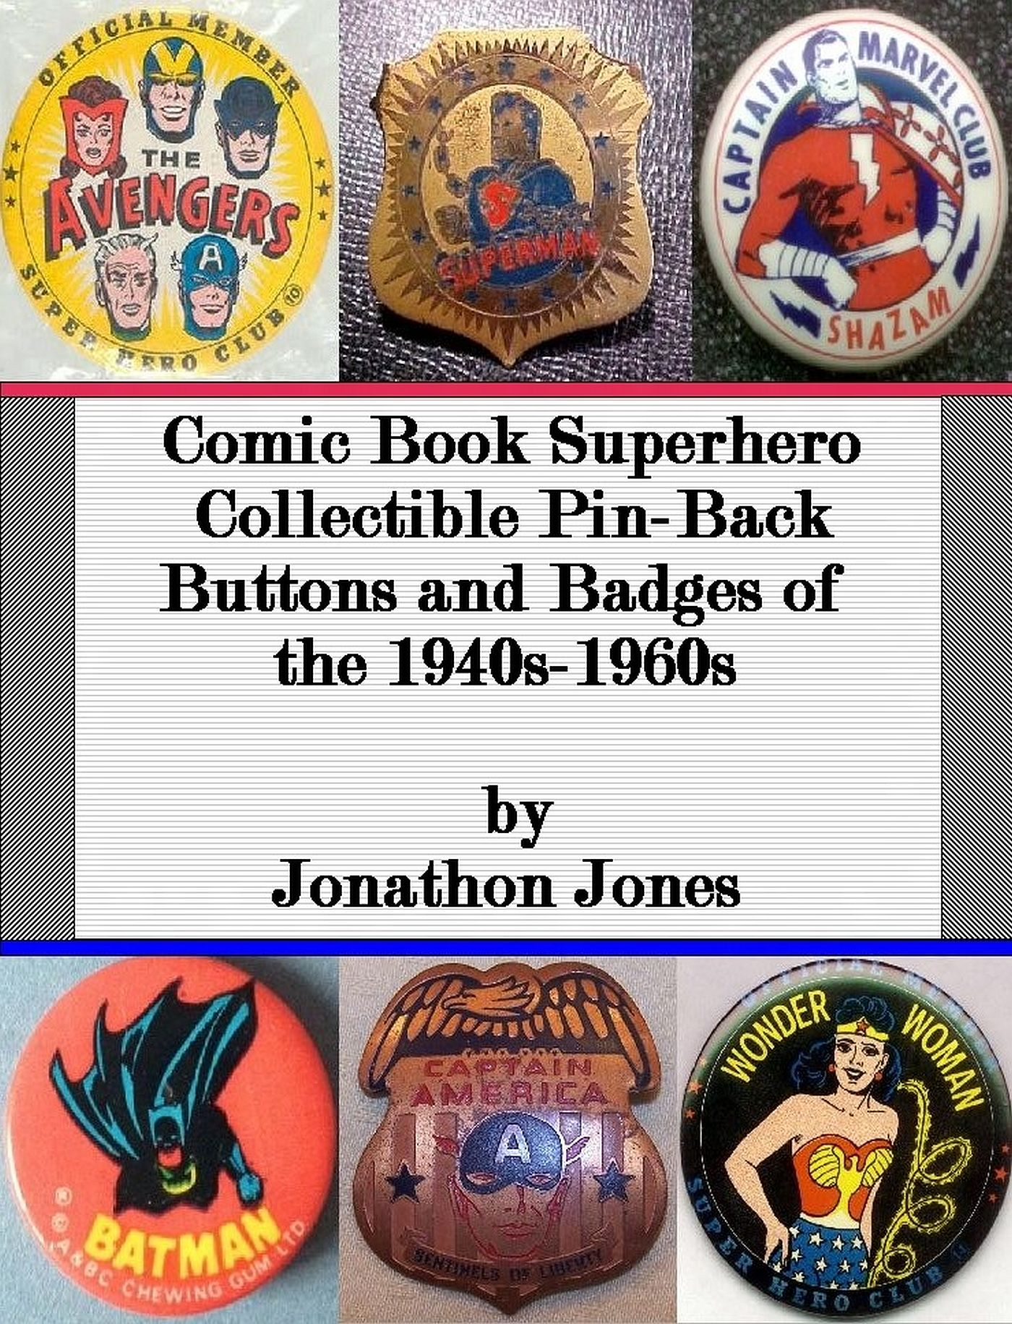

Comic Book Superhero Collectible Pin-Back Buttons and Badges of the 1940s-1960s

by

Jonathon Jones

Copyright 2015 by Jonathon Jones
License Notes:
This ebook is licensed for your personal enjoyment only. This ebook may not be re-sold or given away to other people. If you would like to share this book with another person, please purchase an additional copy for each recipient.

All Ebook Editions:
All characters, comic books, brand names, trademarks, products, television shows, movies, cartoons, companies and manufacturers shown or listed on the cover and inside of this book that are still in existence and/or are being used today are © 2015 and beyond for their respective copyright holders. All rights reserved.

Author Note:
The opinions on all items contained within this ebook are solely based on manufactured items that were produced in the 1940’s-1960’s, and the opinions on the characters that are represented are solely based on one author’s opinion and are only meant to convey a personal preference. These opinions in no way should be interpreted as being directed towards anything except remnants of the past, nor are they intended to steer potential buyers to or away from any current superhero character’s likeness.
Table of Contents:

Introduction
Aquaman
Avengers
Batman
Captain America
Captain Battle
Captain Marvel
Daredevil
Eagle
Fantastic Four
The Flash
Green Lantern
Hawkman
Incredible Hulk
Iron Man
Junior Justice Society of America
Marvel Batty Bullpen Booster Buttons
Marvel Club Pins
Shield G-Man
Silver Surfer
Spider-Man
Spy Smasher
Sub-Mariner
Superman
Thor
U.S. Jones
Wonder Woman
Unsolved Mysteries
Conclusion

Introduction

The use of pins and, especially badges, has been a long-standing tradition for those companies or people who were bent on finding a way to advertise a particular product, brand name, character, potential position of power such as candidacy for office, or to convey a current status such as an officer of the law. However, in the late 1800s, the majority of pin-back buttons and badges that were released were primarily done for advertising and giveaway purposes, and that tradition continues even to this day.
Overall, pins, which are also referred to as pin-backs and buttons, come in all shapes and sizes and are made from a variety of materials. Vintage pins were often made from early celluloid material, a flammable substance used during the late part of the 19th century and as late as the middle of the 20th century, tin painted lithograph buttons, which are often referred to as tin litho, or sometimes even painted steel pins that were covered with a layer of clear plastic.
Badges came in a multitude of material types. From brass to bronze to copper to steel, a variety of metals were used to create the finished product. Badge identification seems to vary from person to person, so for the purposes of this book a badge will be considered any item that is made entirely of metal with a clasp or pin mechanism on the back or, in rare cases, a non-metal item that is in the typical shape of a badge. As far as condition is concerned, overall most badges are a lot more likely to be in poor shape due to the elements interacting with the metal and not as much paint, if any, to help protect and seal it from the outside air.
Both pin-backs and badges were produced during the 40s-60s, so it gives me great pleasure knowing that I can present all types within the pages of this book. However, while types and materials were varied, and a tremendous variety of advertising and giveaway buttons have been produced, this particular book will focus specifically on a favorite genre of mine, which is Comic Book Superheroes.
From the 1940s to the 1960s, which covers the height of the Golden Age of comic books to the end of the Silver Age of comics, many pins were produced to advertise comic book characters in promotional giveaways, to be included in member club kits, and to be sold directly on store shelves. The 1940s and the 1960s seem to be the most prolific when concerned with pin production, especially 1940s Superman items and 1960s Batman items, which will, overall, be the bulk of items listed and depicted within the pages of this book.
Please note that this guide will only contain character pins and badges of superheroes and superhero types that originated in comic books. Therefore, those characters that ended up in comic books later but actually started out in newspaper comic strips or on radio shows or other venues, such as The Green Hornet, The Phantom, Mandrake the Magician, and Popeye, to name a few, will not be listed. However, the possibility highly exists that I may include them in a different book sometime in the future.
As far as prices of these items are concerned, a truly legitimate reason exists for not including them. Auction prices for superhero memorabilia, especially with the abundance of Marvel and D.C. based movies that have come out and continue to be released, has made the comic book collectibles market extremely unpredictable. One day someone may spend 100.00 on a rare pin, and another day someone may have just seen a new superhero movie, felt inspired, and will turn around and bid 500 on that very same pin. This is why prices for these items will not be listed. They’re just way too sporadic, and auction fever for this type of collectible can easily cause things to get out of hand.
In addition, please be aware that this book will always be incomplete. New finds are being made every day, especially for locally produced items that depicted comic characters for local radio stations or newspaper publications. Local market pins that have never been seen before are always popping up in the auction marketplace, as well as mass-produced pins that were just rarely ever saved and are just now starting to make their appearance known. Therefore, always be on the lookout for new finds!
But for now, sit back, and get ready for a fun and visually rewarding experience, and be prepared to be in awe of the sheer abundance of some of the many fun comic book pin collectibles that were produced during these three very important decades.

Aquaman

Aquaman is often given a bad rap in the comic book world. Sure, he talks to fish, wears scaly looking tights, is a blonde pretty-boy, and isn’t even a fraction as strong as Superman. But does that really matter? Let’s face it, if we had the option of being able to breathe under water and escape the lunacy of this world any time we wanted to, but still exist on land with enough strength to lift a semi over our heads, most of us wouldn’t mind looking like a Ken doll dressed in ugly colored spandex.
Overall, unbeknownst to non-comic collectors, Aquaman has actually stood the test of time. First appearing in a side story in More Fun Comics #73 by D.C. Comics way back in 1941, he managed to hang in there, but without much popularity. However, with the inclusion of Aquaman in the Justice League of America starting with the Brave and the Bold comic book issue #28 back in 1960, he has since become an iconic part of the D.C. Comics universe.
Although his popularity increased during the 60s, the amount of Aquaman memorabilia is still quite scarce from that time period, and I have yet to find anything from the 40s or 50s. This solitary pin is one of the few 1960s items produced with his character likeness. Manufactured by Button World Manufacturing Company out of Brooklyn, New York in 1966, it is 3 ½ inches in size, and is numbered 15 of a series. Please note that, when found loose, Button World pins should have an acetate-vinyl based/plastic-like covering over the pin itself. If that is missing, it is not only incomplete, but it will allow the pin to develop scratches and rusting if it does not have those problems already.
Button World Aquaman Pin:
(Warning: Reproductions exist! PS-Notice the lighter blue shade on the original)



